Preliminary Water Balance Assessment for a
Large Open Pit Mine:
A Case Study of Detour Lake Mine, Ontario, Canada

Isaiah Ephraim
B.Eng Mining Engineering, Federal University of Technology, Akure, Nigeria
Mine Water and the Environment

Abstract
Large open pit mines collect significant volumes of water from rainfall, snowmelt, and groundwater seepage. Managing this water, knowing how much arrives, when it arrives, and where it goes, is essential for keeping a mine operational and environmentally compliant. Without a reliable water balance, mines risk flooding pit floors, exceeding storage capacity, or running short of process water during dry periods.
This study develops a preliminary water balance for the Detour Lake open pit mine in northeastern Ontario, Canada. The mine sits in a northern climate that receives around 806 mm of precipitation per year, with most of it falling as snow and releasing rapidly during spring snowmelt. That seasonal pulse is the central water management challenge at this site.
Water entering the pit was estimated from four sources: direct rainfall onto the pit floor, surface runoff from surrounding land, spring snowmelt, and groundwater seeping through the pit walls. The groundwater component was taken from a companion study (Ephraim, 2025) that applied the Thiem analytical radial flow equation to the Detour Lake geology, producing inflow estimates ranging from 761 m³/day under conservative bedrock conditions to 76,079 m³/day where shear zone conductivity was applied. Water leaving the system was estimated from evaporation off the pit water surface, water consumed by the processing plant at 55,000 tonnes of ore per day, and minor losses through the tailings storage facility. The balance was evaluated using a mass conservation approach, equating total inflows against total outflows and change in storage over annual and seasonal timesteps. All data used in this study are publicly available, no proprietary mine records were required.
The results show a predictable seasonal pattern. Water accumulates faster than it can be managed during spring and early summer, with peak monthly inflow during April reaching approximately 1.506 Mm³ under baseline conditions. By late summer, evaporation and plant demand bring the balance closer to neutral. The mine's 3.5-million-cubic-metre storage pond handles normal years comfortably, but a wet year pushes it noticeably closer to its limits. Under fracture-enhanced shear zone conditions, groundwater inflow alone generates a surplus of 27.2 Mm³/yr, an order of magnitude larger than the mine water pond capacity, confirming that shear zone hydraulic conductivity characterisation is the critical uncertainty for operational water management at this site.
This assessment provides a practical starting point for detailed dewatering and water management planning at Detour Lake. Under fracture-enhanced shear zone conditions, groundwater inflow alone generates a surplus of 27.2 Mm³/yr, an order of magnitude larger than the mine water pond capacity, confirming that shear zone hydraulic conductivity characterisation is the critical uncertainty for operational water management at this site. This work builds directly on the preceding groundwater inflow study at the same site, demonstrating a replicable two-stage analytical framework for mine water management in data-limited settings.

Keywords: open pit mine, water balance, mine dewatering, northern Ontario, snowmelt hydrology, Detour Lake, groundwater inflow, Thiem equation, tailings management

1. Introduction
Water management at open pit mines is not a secondary concern, it is one of the conditions that determines whether a mine operates safely and profitably. Every open pit intercepts natural water pathways. Rain falls directly onto exposed pit floors. Groundwater seeps through pit walls. In northern climates, snowmelt delivers large volumes of water in a matter of weeks. If that water is not accounted for, it accumulates in the pit sump, destabilises slopes, dilutes process reagents, and can force production shutdowns.
The standard tool for anticipating these risks is the water balance, a systematic accounting of all water entering and leaving a mine system over time. A preliminary water balance does not require a full numerical model or years of site monitoring data. It requires a clear framework, defensible estimates for each component, and an honest account of what is uncertain. For mines in the planning or early operational phase, that is often the most useful starting document available.
Detour Lake mine sits in the Abitibi greenstone belt of northeastern Ontario, Canada, and is one of the largest open pit gold operations in the country. The site is hydrologically demanding. Annual precipitation averages 806 mm, most of it falling as snow and releasing as a concentrated spring pulse over a few weeks. The terrain is low-relief glaciated landscape, numerous lakes, ponds, and streams, which complicates catchment delineation. Groundwater flows generally northward through a fractured rock and overburden system. These characteristics make Detour Lake a practical and relevant case study for water balance assessment in cold-climate open pit mining.
This study constructs that balance using only publicly available data: the 2018 NI 43-101 Technical Report (Detour Gold Corporation, 2018), Environment and Climate Change Canada climate records, NASA POWER solar radiation data, and the Canadian Digital Elevation Model. No proprietary site monitoring data were used. That constraint was imposed deliberately, to test how far a rigorous water balance can be taken using only information that any researcher can access and verify independently.
The groundwater inflow component draws from a companion study (Ephraim, 2025), which estimated steady-state inflow to the Detour Lake pit using the Thiem radial flow equation. That result is carried forward here as the hydrogeological input to the broader balance. The two papers together form a sequential framework, groundwater characterisation followed by full water budget assessment, that can be applied to other large open pit operations in similar settings.
Three questions drive this study. How much water enters and leaves the Detour Lake pit system, and when? Does existing storage infrastructure hold up under wet-year conditions? And which components of the balance carry the most uncertainty and therefore deserve the most attention in future monitoring programmes?

2. Study Area

2.1 Location and mine overview
Detour Lake mine sits in the northeastern corner of Ontario, Canada, roughly 260 km northeast of Timmins and 185 km northeast of Cochrane, within the Abitibi greenstone belt. The coordinates are 50.02°N, 79.72°W. Elevation across the property runs from 260 to 288 metres above sea level, and the surrounding terrain is flat by most standards, glacially reworked Canadian Shield country, with a maximum local relief of about 30 metres (Detour Gold Corporation, 2018).

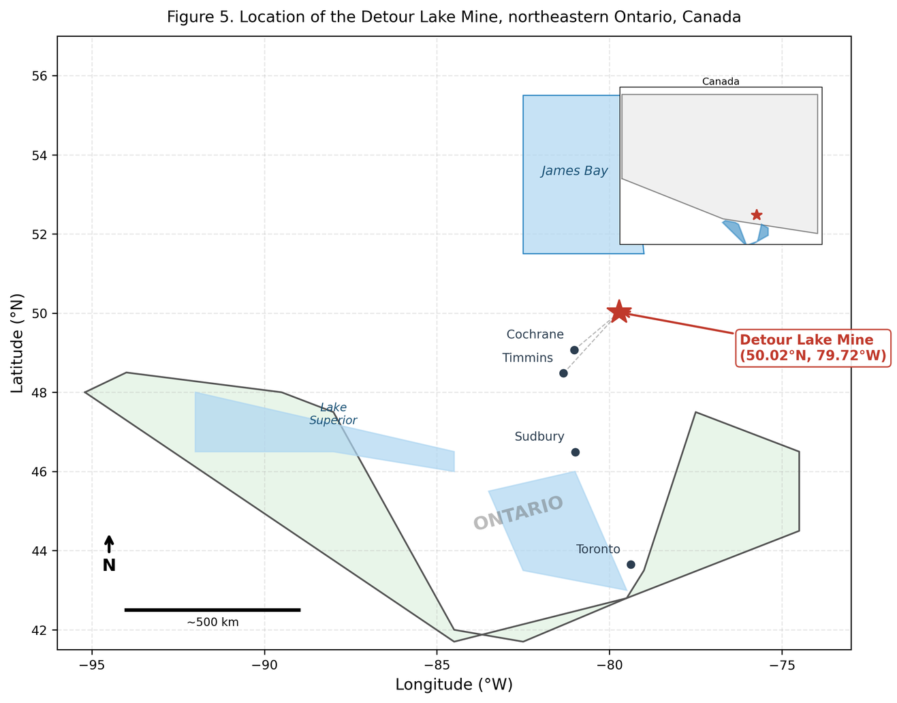
Figure 5. Location of the Detour Lake Mine, northeastern Ontario, Canada. The mine sits approximately 260 km northeast of Timmins and 185 km northeast of Cochrane at coordinates 50.02°N, 79.72°W. Inset shows the location of Ontario within Canada.
The operation is large. The mine processes around 55,000 tonnes of ore per day, with an annual throughput target of 23 million tonnes. Infrastructure on site includes the main open pit, a West Detour pit, a North pit, a processing plant, a tailings management area east of the plant, and a mine water pond with a 3.5 million cubic metre capacity, completed in 2020.

2.2 Climate
The site has a humid continental climate, cold winters, short summers, and a hydrology that runs on a tight seasonal clock. Mean annual temperature is 0.5°C. January averages -18.7°C; July averages 16.5°C. The ground stays frozen for several months, which matters for hydrology because frozen ground stores precipitation as snowpack rather than letting it infiltrate or run off immediately (Detour Gold Corporation, 2018).
Mean annual precipitation is 806 mm, based on data from three regional climate stations reported in the 2018 Technical Report. Rain falls from June through October. Snow covers the rest of the calendar. Wind averages 12.6 km/h from the west year-round, which affects evaporation rates at the pit sump and tailings pond.
The event that sets the tempo for water management at this site is the spring snowmelt. When the snowpack breaks down over April and May, it releases water that has been accumulating since November, all at once, over a few weeks. Groundwater levels rise, surface runoff increases, and evaporation is still too low to compensate. That is when storage infrastructure is under the most pressure, and it is the scenario this water balance pays closest attention to.

2.3 Hydrogeological setting
The property sits on Archean metavolcanic and metasedimentary rocks, intruded by granitoid bodies, within the Abitibi greenstone belt. Groundwater moves through fractures in these crystalline rocks, with the overlying glacial overburden, ranging from approximately 5 to 30 m in thickness, providing additional near-surface permeability. Regional flow is directed generally northward toward natural discharge areas (Detour Gold Corporation, 2018).
The water table is shallow in low-lying areas, where it connects directly to the lakes, ponds, and streams that cover the landscape. Sunday Lake, the largest nearby water body at roughly 1 km² surface area, sits close enough to the pit to act as a boundary condition on groundwater inflow. The smaller waterbodies across the property are oriented parallel to glacial fluting, which reflects the direction of ice movement that shaped this terrain (Detour Gold Corporation, 2018).
Hydraulic conductivity in the fractured rock ranges from 1×10⁻⁸ to 1×10⁻⁵ m/s, with shear zones at the upper end of that range. The overburden is more permeable and contributes more actively to pit wall seepage during spring, when snowmelt recharge pushes the water table toward the surface (Duquette et al., 2024).

2.4 Water management infrastructure
Three systems handle water on site. The tailings management area, east of the processing plant, uses a centerline construction design across three planned cells, Cell 1 is operating, Cells 2 and 3 are planned, with a total planned capacity of 660 million tonnes. Six seepage collection ponds ring Cell 1, and collected seepage is pumped back to the decant pond rather than discharged.
Process water comes primarily from the TMA decant pond. East Lake supplies fresh makeup water when reclaim is insufficient. Dewatering discharge from the pit goes to the process plant or TMA depending on operational needs. The mine water pond, 3.5 Mm³, completed in 2020, is the main buffer against peak inflow events (Detour Gold Corporation, 2018).

3. Literature Review and Theoretical Background

3.1 Water balance in mining environments
The water balance in mining is an old idea dressed in increasingly complicated clothing. The underlying principle, inflows minus outflows equals change in storage, comes from classical hydrology and has not changed since Freeze and Cherry (1979) formalised the mass conservation framework that most mine water assessments still use today. What has changed is the regulatory weight placed on it. A water balance is no longer just a planning tool. In most jurisdictions, including Ontario, it is a permitting requirement. Mine operators must demonstrate that their water management infrastructure can contain and manage all water generated on site without uncontrolled discharge to surrounding water bodies (INAP, 2009). The Detour Lake mine operates under those requirements, and this study is framed accordingly.

3.2 Open pit hydrology
An open pit changes the landscape it sits in. It intercepts groundwater that would otherwise move laterally through the rock, captures runoff from surrounding land, and collects rain and snow over an area that grows larger as mining deepens. Understanding the water behaviour of a pit means understanding all three of those processes simultaneously.
Groundwater inflow has been the most studied of the three. The analytical approach used in the companion study, the Thiem radial flow equation, treats the pit as a large-radius well drawing from a homogeneous aquifer. Freeze and Cherry (1979) describe the theoretical basis in detail; Thiem (1906) established the original formulation. The method works well for preliminary estimates. Its main weakness in fractured crystalline rock, like the Archean geology at Detour Lake, is that real hydraulic conductivity is neither homogeneous nor isotropic. Flow follows fractures, not averages. That limitation is acknowledged here and is one reason this assessment is described as preliminary rather than definitive.
Numerical groundwater models handle that complexity better. MODFLOW and FEFLOW can accommodate variable aquifer properties, transient conditions, and irregular pit geometries (Todd and Mays, 2005). They are the appropriate tool for detailed dewatering design.
Surface runoff into pits gets less attention in the literature than groundwater, partly because it is easier to estimate and partly because in many mining regions it is small. In northern Canada it is not small. Woo (2012) documents the hydrology of cold regions relevant to the Canadian Shield, specifically the processes that compress months of accumulated precipitation into a few weeks of spring runoff. At Detour Lake, that pulse is the largest single inflow event of the year.

3.3 Water balance methods
Mine water balance methods range from simple annual spreadsheets to probabilistic simulation models. The most widely used probabilistic platform in Canadian mining is GoldSim, which runs Monte Carlo simulations to propagate uncertainty through each water balance component and produce outcome distributions rather than single estimates (GoldSim Technology Group, 2010). Detour Lake itself uses a GoldSim model, updated monthly and calibrated twice yearly by BGC Engineering Inc., as documented in operational audit records.
This study uses a deterministic approach. The goal is not to replicate the mine's operational model but to build an independent estimate from public data that any researcher can verify and reproduce. Where key parameters are uncertain, the runoff coefficient, TMA seepage rate, a sensitivity analysis bounds the plausible range, consistent with guidance from INAP (2009) for preliminary assessments.
The mass conservation equation follows Younger and Wolkersdorfer (2004):
ΔS = (P + Q_in + GW_in) − (E + Q_out + W_process + S_tma)

3.4 Northern climate considerations
The hydrology of northeastern Ontario does not behave like most of the world's major mining regions. The dominant process is not rainfall but snowpack accumulation and release. Snow builds from November through March. It melts over three to six weeks in April and May. Peak inflows during that window can exceed any other month by a factor of three or more (Pomeroy and Gray, 1995).
That seasonal compression matters for storage design. A system sized for average annual conditions fails during the spring pulse. A system sized for the spring peak sits empty most of the year. Neither extreme is right, and finding the balance between them requires seasonal timestep analysis, which is why this study evaluates the water balance monthly rather than just annually.
Evaporation at Detour Lake is also different from arid mining regions. The pit sump and TMA surface are ice-covered from roughly November through April. Evaporation only operates for about six months of the year. At operations in Western Australia or the Atacama, evaporation runs year-round and often dominates the outflow side of the balance. At Detour Lake it is a secondary term, real but not controlling. That distinction shapes which components the sensitivity analysis pays most attention to.

4. Data Sources

4.1 Mine technical report
The main source of site-specific data is the NI 43-101 Technical Report for Detour Lake Mine, prepared in 2018 and filed publicly on SEDAR+ (Detour Gold Corporation, 2018). It provided climate parameters, hydrogeological descriptions, infrastructure specifications, process plant throughput figures, and water management details. Data drawn from this report are referenced by section number throughout the paper. The report is freely available to any researcher.

4.2 Climate and precipitation data
Mean annual temperature, seasonal temperature range, total annual precipitation, wind speed, and wind direction all came from Section 5.2 of the Technical Report, which compiled readings from three regional climate stations. Monthly climate normals for seasonal breakdown of rainfall and snowfall were obtained from Environment and Climate Change Canada at climate.weather.gc.ca. The two nearest long-record stations are Cochrane and Kapuskasing, both maintained by ECCC.

4.3 Solar radiation and evaporation inputs
Evaporation from the pit sump was estimated using the Penman equation (Penman, 1948), which needs solar radiation, temperature, wind speed, and humidity. Temperature and wind speed came from the Technical Report. Solar radiation and relative humidity were obtained from the NASA POWER database, a free platform run by NASA's Langley Research Centre that delivers gridded climate data at any point on Earth. Data were extracted at 50.02°N, 79.72°W, the verified coordinates for the Detour Lake mine site.

4.4 Catchment area and elevation data
The contributing catchment area for surface runoff was delineated from the Canadian Digital Elevation Model, distributed freely by Natural Resources Canada through the GeoGratis portal. The DEM resolution is 20 metres, adequate for catchment work in the flat glaciated terrain around Detour Lake. Watershed boundaries were defined using standard GIS delineation tools.

4.5 Groundwater inflow
Groundwater inflow was not re-estimated here. The value comes directly from the companion study (Ephraim, 2025), which applied the Thiem radial flow equation to the Detour Lake pit geometry using publicly available hydrogeological data. Two scenarios bracket the expected inflow range: a conservative bedrock case (K = 1×10⁻⁷ m/s, Q = 761 m³/day) and a fracture-enhanced case (K = 1×10⁻⁵ m/s, Q = 76,079 m³/day). Reusing these results keeps the two papers consistent and avoids repeating work already documented elsewhere.

4.6 What the data could not provide
Three components had no directly measured values available. Evaporation was calculated, not measured. The surface runoff coefficient was estimated from published ranges for glaciated low-relief terrain, no site-specific rainfall-runoff records exist in the public domain for this property. TMA seepage rates were bounded using industry literature ranges because the 2018 Technical Report describes the seepage collection system qualitatively but gives no flow figures.

5. Methodology

5.1 Water balance framework
The water balance was constructed using the mass conservation equation:
ΔS = (P + Q_in + GW_in) − (E + Q_out + W_process + S_tma)
The terms are defined as follows: ΔS = change in storage in pit sump and mine water pond (m³); P = direct precipitation on pit surface (m³); Q_in = surface runoff from surrounding catchment (m³); GW_in = groundwater inflow through pit walls and floor (m³); E = evaporation from pit sump water surface (m³); Q_out = dewatering pump discharge (m³); W_process = net water consumed by processing plant (m³); S_tma = net seepage loss from the tailings management area (m³).
The balance was evaluated on monthly and annual timesteps. The monthly resolution matters here because the spring snowmelt pulse and the late summer drawdown behave very differently, and an annual average hides both.

5.2 Direct precipitation on pit surface
Precipitation falling directly onto the pit was calculated as P = p × A_pit, where p is precipitation depth in metres and A_pit is the pit surface area in square metres. Based on the equivalent pit radius of 1,200 m from Ephraim (2025), the circular pit area is 4,523,893 m² (452 ha). The base precipitation value of 0.806 m/yr came from Section 5.2 of the 2018 Technical Report.
Monthly distribution followed mean temperature. Months averaging below 0°C were treated as snowfall and accumulated as snowpack. Months above 0°C were treated as rainfall. The accumulated snowpack was released as a melt pulse in April and May, consistent with northern Ontario melt patterns documented by Pomeroy and Gray (1995).

5.3 Surface runoff
Surface runoff was estimated using the Rational Method: Q = C · i · A, where C is the runoff coefficient, i is rainfall intensity (mm/hr), and A is contributing catchment area (ha). The Rational Method is standard practice for preliminary runoff estimation in mine water balance work and is strictly appropriate for catchments up to roughly 80 ha (Chow et al., 1988). The contributing catchment estimated here at 1,131 ha exceeds this limit; however, in the absence of site-specific rainfall-runoff data the method is retained as a first-order estimate at the preliminary stage, with this simplification noted as a source of uncertainty and captured in the precipitation sensitivity analysis.
A runoff coefficient of 0.35 was used, sitting in the middle of the published range for low-relief glaciated terrain with mixed forest cover and shallow soils over bedrock (Chow et al., 1988). The contributing catchment area was estimated at 2.5 times the pit area (1,131 ha), consistent with the subdued topography of the site. Snowmelt runoff was applied as a discrete event split between April (60%) and May (40%), based on observed melt timing in comparable northern Ontario catchments (Woo, 2012). A higher runoff coefficient of 0.80 was applied to snowmelt, reflecting frozen ground conditions that limit infiltration.

5.4 Groundwater inflow
Steady-state groundwater inflow was taken directly from Ephraim (2025), where the Thiem equation was applied:
Q = (2π · K · b · (h₂ − h₁)) / ln(r₂ / r₁)
with pit radius r₁ = 1,200 m, radius of influence r₂ = 5,000 m, saturated thickness b = 200 m, and head difference Δh = 100 m. Two scenarios were carried forward: Scenario 1 (conservative bedrock, K = 1×10⁻⁷ m/s, Q = 761 m³/day = 0.278 Mm³/yr) and Scenario 2 (fracture-enhanced, K = 1×10⁻⁵ m/s, Q = 76,079 m³/day = 27.769 Mm³/yr). For the seasonal distribution, the annual steady-state estimate was held constant across all months, a simplification that is conservative and defensible at a preliminary stage.

5.5 Evaporation
Open water evaporation from the pit sump was estimated using the Penman combination equation (Penman, 1948): E = (Δ · Rn + γ · Ea) / (Δ + γ), where Δ is the slope of the saturation vapour pressure curve (kPa/°C), Rn is net radiation at the water surface, γ is the psychrometric constant, and Ea is the aerodynamic evaporation term. Mean monthly temperature and wind speed came from the 2018 Technical Report; solar radiation and relative humidity from NASA POWER at 50.02°N, 79.72°W. Evaporation was set to zero for months where mean temperature fell below 0°C. The pit sump freezes over in winter. No evaporation occurs from ice.

5.6 Process plant water demand
The plant runs at 55,000 tonnes per day, around 20 million tonnes per year. Process water comes primarily from TMA decant reclaim, with East Lake as a backup fresh water source (Detour Gold Corporation, 2018, Section 17.4.2). Net consumptive demand, water that does not return to the system, was estimated at 0.3 m³ per tonne of ore, covering water retained in tailings and evaporated within the circuit. Published consumption factors for gold cyanide leach circuits typically range from 0.2 to 0.5 m³/tonne depending on circuit configuration and tailings moisture content (Norgate and Lovel, 2006); 0.3 m³/tonne represents the lower end of this range and is therefore a conservative estimate of net demand.

5.7 TMA seepage
The 2018 Technical Report describes the TMA seepage collection system in detail but gives no flow measurements. Seepage loss was estimated as a percentage of impounded volume, using the 0.1% to 1.0% per year range reported for partially lined tailings facilities (ICOLD, 2001; Vick, 1990). The base case used 0.5%. Six seepage collection ponds ring TMA Cell 1, recovering an estimated 50% of gross seepage.

5.8 Sensitivity analysis
Three parameters carry the most uncertainty in this assessment. Each was varied individually while the others stayed at their base case values: precipitation (±20% of 806 mm); groundwater inflow (±15%, reflecting parameter uncertainty from Ephraim (2025)); and TMA seepage (full range of 0.1% to 1.0% of impounded volume per year). The purpose is practical, to find out which parameter, if wrong, changes the answer most.

6. Results

6.1 Pit geometry and catchment area
Based on the equivalent pit radius of 1,200 m from Ephraim (2025), the Detour Lake open pit has a circular surface area of approximately 4.52 km² (452 ha). The contributing surface catchment was estimated at 11.31 km², approximately 2.5 times the pit area, consistent with the low local relief of around 30 m described in the Technical Report. Flat terrain means water from a wide surrounding area drains toward the pit rather than away from it.

6.2 Precipitation and snowmelt
Annual precipitation of 806 mm splits into roughly 255 mm of snow water equivalent, falling between November and March, and 551 mm of rainfall between April and October. That winter snowpack builds up over five months and then releases over about six weeks in April and May. The result is a concentrated spring inflow pulse that no other month comes close to matching.

6.3 Annual water balance
Table 1 summarises the annual balance under both groundwater scenarios.

Table 1. Annual water balance, Detour Lake open pit (Mm³/yr)
Component | Type | Scenario 1 (Conservative) | Scenario 2 (Fracture-enhanced)
Direct precipitation on pit | Inflow | 3.646 | 3.646
Surface runoff | Inflow | 4.489 | 4.489
Groundwater inflow* | Inflow | 0.278 | 27.769
Total inflow | — | 8.413 | 35.905
Evaporation from pit sump | Outflow | 2.300 | 2.300
Process plant net demand | Outflow | 6.022 | 6.022
TMA net seepage | Outflow | 0.354 | 0.354
Total outflow | — | 8.676 | 8.676
Net ΔS (before dewatering) | — | -0.263 (deficit) | +27.228 (surplus)
*Scenario 1: K = 1×10⁻⁷ m/s, Q = 761 m³/day. Scenario 2: K = 1×10⁻⁵ m/s, Q = 76,079 m³/day. Source: Ephraim (2025).

Surface runoff is the largest inflow component at 4.489 Mm³/yr (53% of total under Scenario 1), followed by direct precipitation at 3.646 Mm³/yr (43%). On the outflow side, process plant demand dominates at 6.022 Mm³/yr, 69% of all outflow under Scenario 1. Evaporation contributes 2.300 Mm³/yr and TMA seepage 0.354 Mm³/yr.
The two scenarios produce dramatically different outcomes. Under conservative bedrock conditions, the system runs at a modest annual deficit of 0.263 Mm³/yr, manageable within the mine water pond buffer. Under fracture-enhanced conditions, groundwater inflow alone generates a surplus of 27.228 Mm³/yr, demanding a major continuous dewatering programme.

6.4 Monthly water balance
Tables 2 and 3 present the monthly water balance under Scenario 1 and Scenario 2 respectively. Figures 1 and 2 show the same data visually. The seasonal pattern under Scenario 1 is clear, April and May are the only two months where inflows reliably exceed outflows, driven by the snowmelt pulse. Peak monthly inflow reaches 1.506 Mm³ in April, equivalent to 43% of the mine water pond capacity in a single month. From June onward, the balance turns negative as runoff declines and process plant demand runs continuously at 0.502 Mm³/month regardless of season.

Table 2. Monthly water balance, Detour Lake open pit, Scenario 1 conservative (Mm³)
Month | Precip mm | Runoff Mm³ | GW Mm³ | Evap Mm³ | Process Mm³ | Net ΔS Mm³ | Cumulative Mm³
Jan | 44.8 | 0.000 | 0.023 | 0.000 | 0.502 | -0.306 | -0.306
Feb | 40.3 | 0.000 | 0.023 | 0.000 | 0.502 | -0.326 | -0.632
Mar | 49.3 | 0.000 | 0.023 | 0.000 | 0.502 | -0.285 | -0.917
Apr | 62.7 | 1.386 | 0.023 | 0.103 | 0.502 | +1.058 | +0.141
May | 76.1 | 1.225 | 0.023 | 0.302 | 0.502 | +0.759 | +0.900
Jun | 85.1 | 0.337 | 0.023 | 0.439 | 0.502 | -0.225 | +0.675
Jul | 94.0 | 0.372 | 0.023 | 0.501 | 0.502 | -0.212 | +0.463
Aug | 85.1 | 0.337 | 0.023 | 0.464 | 0.502 | -0.250 | +0.213
Sep | 76.1 | 0.301 | 0.023 | 0.327 | 0.502 | -0.189 | +0.024
Oct | 71.6 | 0.284 | 0.023 | 0.165 | 0.502 | -0.066 | -0.042
Nov | 67.2 | 0.000 | 0.023 | 0.000 | 0.502 | -0.204 | -0.246
Dec | 53.7 | 0.000 | 0.023 | 0.000 | 0.502 | -0.265 | -0.511

Winter months under Scenario 1, January through March and November through December, run at a steady deficit of 0.27–0.33 Mm³/month. No runoff, no evaporation, just process demand and a small constant groundwater contribution slowly drawing down whatever storage the spring built up.

Table 3. Monthly water balance, Detour Lake open pit, Scenario 2 fracture-enhanced (Mm³)
Month | Precip mm | Runoff Mm³ | GW Mm³ | Evap Mm³ | Process Mm³ | Net ΔS Mm³ | Cumulative Mm³
Jan | 44.8 | 0.000 | 2.314 | 0.000 | 0.502 | +1.985 | +1.985
Feb | 40.3 | 0.000 | 2.314 | 0.000 | 0.502 | +1.965 | +3.950
Mar | 49.3 | 0.000 | 2.314 | 0.000 | 0.502 | +2.006 | +5.956
Apr | 62.7 | 1.386 | 2.314 | 0.103 | 0.502 | +3.349 | +9.305
May | 76.1 | 1.225 | 2.314 | 0.302 | 0.502 | +3.050 | +12.355
Jun | 85.1 | 0.337 | 2.314 | 0.439 | 0.502 | +2.066 | +14.421
Jul | 94.0 | 0.372 | 2.314 | 0.501 | 0.502 | +2.079 | +16.500
Aug | 85.1 | 0.337 | 2.314 | 0.464 | 0.502 | +2.041 | +18.541
Sep | 76.1 | 0.301 | 2.314 | 0.327 | 0.502 | +2.102 | +20.642
Oct | 71.6 | 0.284 | 2.314 | 0.165 | 0.502 | +2.225 | +22.868
Nov | 67.2 | 0.000 | 2.314 | 0.000 | 0.502 | +2.087 | +24.954
Dec | 53.7 | 0.000 | 2.314 | 0.000 | 0.502 | +2.026 | +26.980

Under Scenario 2 the monthly picture is completely different. Groundwater inflow of 2.314 Mm³/month exceeds total outflows in every single month of the year. Even in January, when there is no runoff and no evaporation, the system generates a surplus of 1.985 Mm³. By the end of April the cumulative surplus already exceeds the mine water pond capacity of 3.5 Mm³, and by December it reaches 26.980 Mm³. There is no season under Scenario 2 when the pit is not generating water faster than process demand and evaporation can remove it.

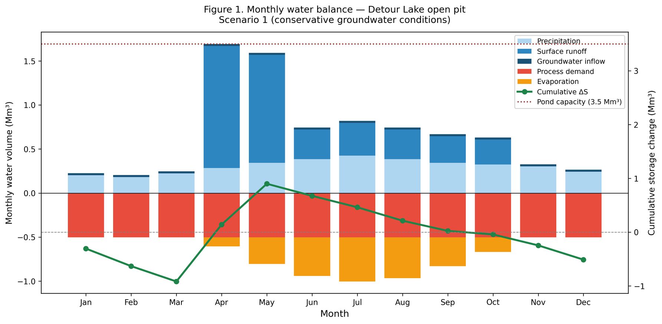
Figure 1. Monthly water balance, Detour Lake open pit, Scenario 1 (conservative bedrock, K = 1×10⁻⁷ m/s, Q = 761 m³/day). Bars show inflow components (precipitation, surface runoff, groundwater) and outflow components (process demand, evaporation). Line shows cumulative storage change against the mine water pond capacity (dotted red line = 3.5 Mm³).

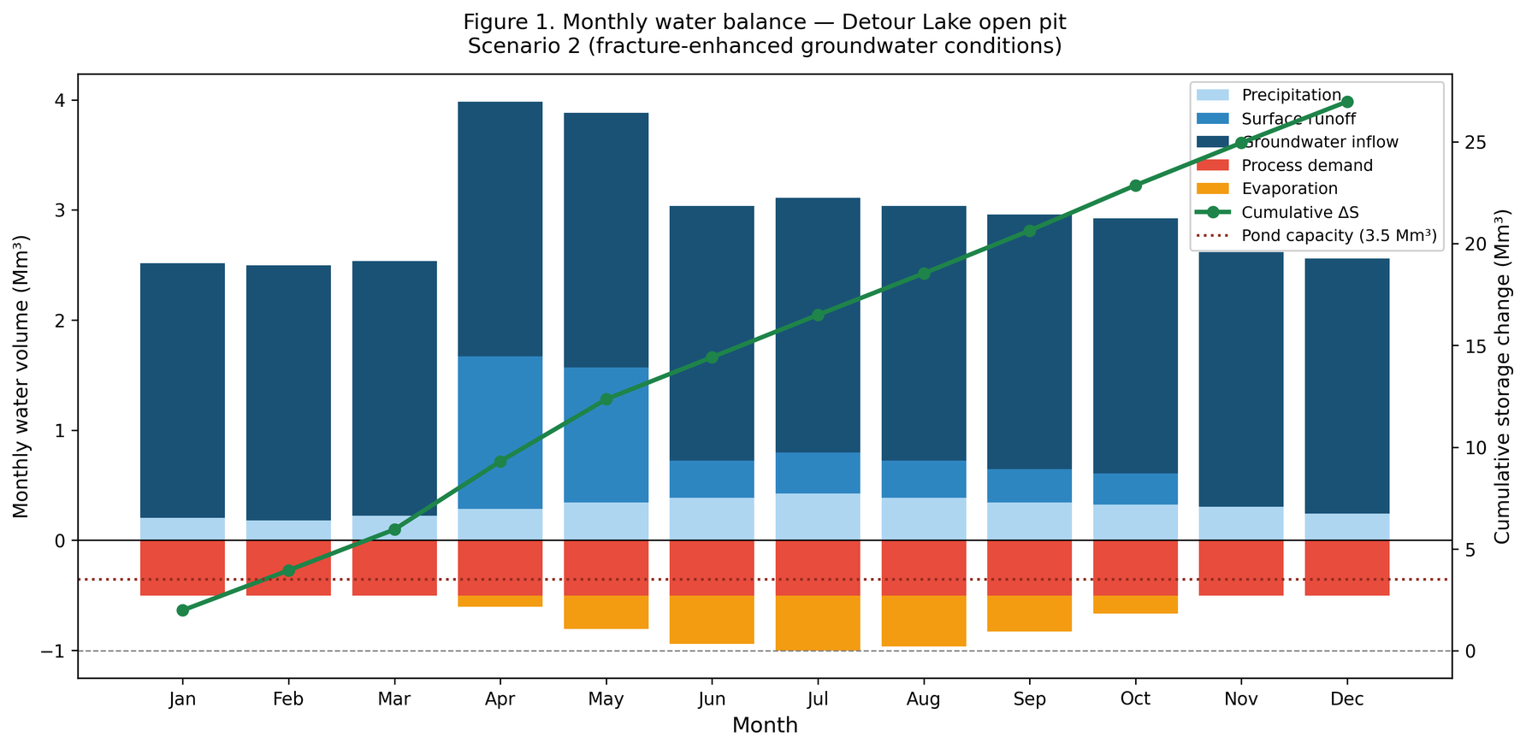
Figure 2. Monthly water balance, Detour Lake open pit, Scenario 2 (fracture-enhanced, K = 1×10⁻⁵ m/s, Q = 76,079 m³/day). Groundwater inflow dominates every month of the year, generating a persistent and large surplus that requires a dedicated high-capacity dewatering programme. Note the difference in vertical scale compared to Figure 1.

6.5 Storage adequacy
Under Scenario 1 base case conditions, the mine water pond's 3.5 Mm³ capacity comfortably absorbs the spring pulse. Cumulative storage peaks at around 0.900 Mm³ in May, well below the pond limit, leaving a buffer of approximately 2.60 Mm³. The pond is not close to overtopping under normal precipitation conditions.
Under Scenario 2, groundwater inflow alone generates 27.769 Mm³/yr, nearly eight times the pond capacity annually. This confirms that fracture-controlled inflow at shear zone intersections requires a dedicated high-capacity dewatering programme, not passive sump management.

6.6 Sensitivity analysis results
Table 4 and Figure 3 summarise the sensitivity of the annual water balance to the three most uncertain parameters under Scenario 1. Table 5 and Figure 4 present the equivalent analysis for Scenario 2.

Table 4. Sensitivity analysis, Scenario 1 (conservative groundwater)
Parameter | Variation | Annual ΔS (Mm³/yr) | Shift from base
Base case | — | -0.263 | —
Precipitation | -20% | -1.890 | -1.627
Precipitation | +20% | +1.364 | +1.627
GW inflow | -15% | -0.305 | -0.042
GW inflow | +15% | -0.221 | +0.042
TMA seepage | 0.1%/yr | +0.020 | +0.283
TMA seepage | 1.0%/yr | -0.617 | -0.354

Precipitation drives the balance more than any other uncertain parameter. A 20% swing in annual rainfall and snowfall shifts the outcome by 1.627 Mm³/yr, roughly 39 times the sensitivity to a 15% variation in groundwater inflow under Scenario 1. TMA seepage barely moves the needle; even at ten times the base case rate, the shift is only 0.354 Mm³/yr.

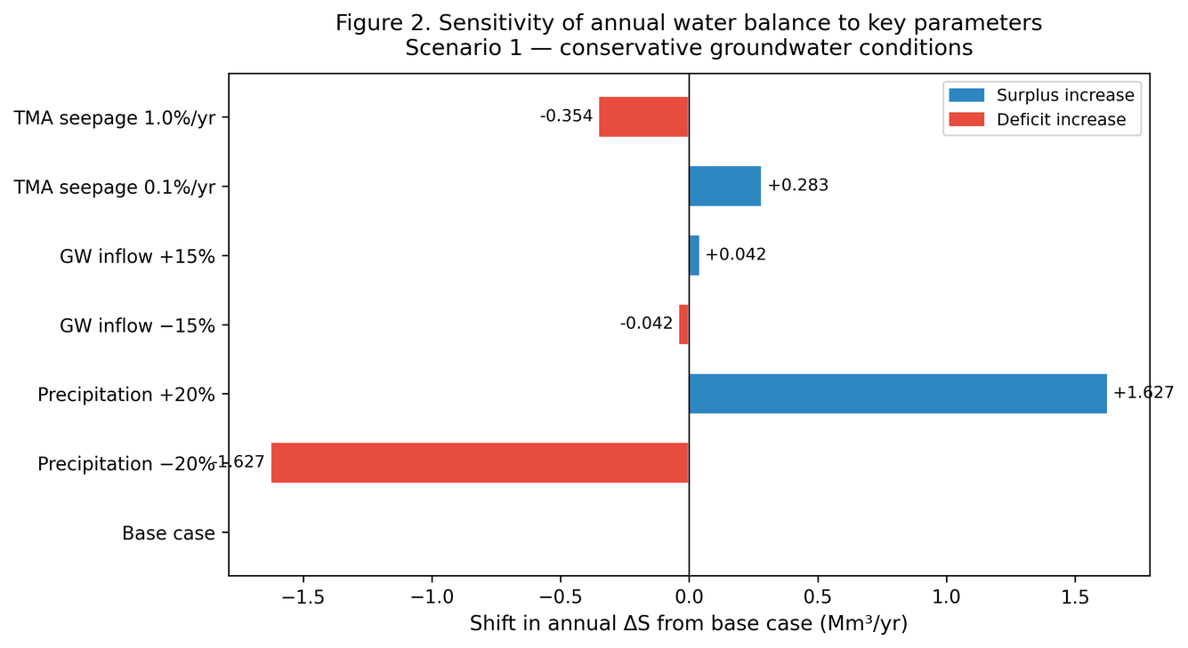
Figure 3. Sensitivity of the annual water balance to key uncertain parameters, Scenario 1 conservative groundwater conditions. Precipitation is the dominant source of uncertainty. A 20% variation shifts the balance by 1.627 Mm³/yr, compared to only 0.042 Mm³/yr for a 15% change in groundwater inflow.

Under Scenario 2, the sensitivity profile changes dramatically. Table 5 and Figure 4 show that groundwater inflow uncertainty now dominates the balance, a 15% variation in K shifts the annual surplus by 4.165 Mm³/yr, compared to only 1.627 Mm³/yr for a 20% change in precipitation. Under fracture-enhanced conditions, getting the hydraulic conductivity right is the single most important data collection priority.

Table 5. Sensitivity analysis, Scenario 2 (fracture-enhanced groundwater)
Parameter | Variation | Annual ΔS (Mm³/yr) | Shift from base
Base case | — | +27.228 | —
Precipitation | -20% | +25.601 | -1.627
Precipitation | +20% | +28.855 | +1.627
GW inflow | -15% | +23.063 | -4.165
GW inflow | +15% | +31.393 | +4.165
TMA seepage | 0.1%/yr | +27.511 | +0.283
TMA seepage | 1.0%/yr | +26.875 | -0.354

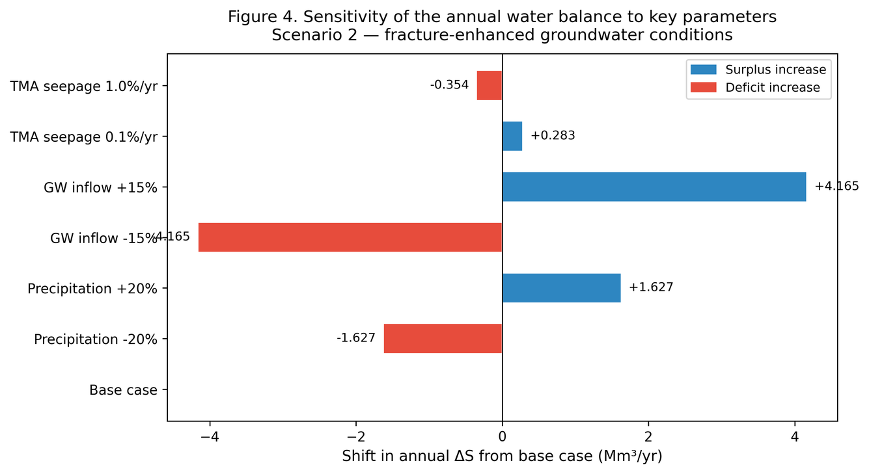
Figure 4. Sensitivity of the annual water balance to key uncertain parameters, Scenario 2 fracture-enhanced groundwater conditions. Groundwater inflow uncertainty now dominates the balance, with a 15% variation in K shifting the surplus by 4.165 Mm³/yr, 100 times the equivalent sensitivity under Scenario 1. Accurate hydraulic conductivity characterisation of shear zones is the highest-priority data collection task under this scenario.

7. Discussion

7.1 What the balance is actually telling us
The clearest finding from this assessment is that the Detour Lake pit water system is not groundwater-dominated under conservative hydrogeological conditions. Surface runoff and direct precipitation together account for around 96% of annual inflow in Scenario 1. The hydrogeology matters, but so does the scenario. Under fracture-enhanced conditions in Scenario 2, groundwater flips from a minor term to the dominant driver, accounting for 77% of total annual inflow.
This two-scenario structure, inherited directly from Ephraim (2025), is one of the most useful features of the combined framework. It does not pretend that a single K value represents the site. It shows the decision-maker the range: if the pit intersects intact fractured rock, water management is manageable. If it intersects active shear zones, it is not. The water balance quantifies the difference. Under Scenario 1, a 20% variation in precipitation shifts the annual balance by 1.627 Mm³/yr. Under Scenario 2, a 15% variation in groundwater inflow shifts it by 4.165 Mm³/yr. The dominant uncertainty is not the same problem in both cases, and the monitoring response should not be either.

7.2 The spring pulse problem
For ten months of the year, the pit runs at a deficit under Scenario 1. Outflows exceed inflows. Storage is being drawn down. Then April arrives, the snowpack breaks, and eight weeks of accumulated winter precipitation releases all at once. That spring pulse is the only period when inflows meaningfully exceed outflows, and it is when the storage system earns its existence.
The numbers bear this out. April inflow reaches 1.506 Mm³ under base case conditions, 43% of the mine water pond capacity in a single month. Under a wet year with 20% above-average precipitation, the pulse grows proportionally and the storage buffer shrinks. The pond handles normal years without difficulty. Wet years leave less room for error.
Woo (2012) documents this pattern across the Canadian Shield boreal zone, the spring freshet as the defining hydrological event of the year, storage systems that must absorb it quickly and release it slowly. Detour Lake fits that description well.

7.3 Process demand runs the show on the outflow side
Process plant water consumption of 6.022 Mm³/yr is 69% of all outflow under Scenario 1. It runs at 0.502 Mm³/month every month, regardless of season or precipitation. January and July look identical on the outflow side of the ledger.
That consistency makes process water reclaim the most important operational lever available. The Technical Report confirms that Detour Lake draws process water primarily from TMA decant reclaim rather than fresh sources (Detour Gold Corporation, 2018). Any drop in reclaim efficiency forces a draw on East Lake and shifts the net consumptive demand upward.

7.4 What this study can and cannot do compared to the mine's own model
Detour Lake runs a GoldSim-based probabilistic water balance model, updated monthly and calibrated twice yearly (GoldSim Technology Group, 2010). This study does not compete with that. The GoldSim model has real operational data, calibrated parameters, and probabilistic confidence intervals that a public-data assessment cannot replicate.
What this study offers instead is independence. Every input is documented, every assumption is stated, and every calculation can be reproduced from scratch by anyone with access to the same public sources. That is a different kind of value, not operational precision, but transparency and transferability. The same framework applies to any large open pit in a similar climate where operational data are not accessible.
The structural conclusions from both approaches agree: spring snowmelt drives peak inflow, process demand drives annual outflow, and the mine water pond is the system's critical buffer under conservative groundwater conditions.

7.5 Operational implications of fracture-enhanced groundwater conditions
Scenario 2 represents a fundamentally different operational challenge. A groundwater inflow of 76,079 m³/day requires continuous high-capacity pumping, at 880 L/s, this demands multiple large-diameter submersible pump strings operating in parallel ahead of the advancing pit face. The mine water pond capacity of 3.5 Mm³ would be filled in approximately 46 days under these conditions and cannot function as a buffer. A dedicated dewatering bore field, with wells targeting shear zones specifically, would be required before pit deepening progresses beyond the current level.
The practical implication for mine planning is that the transition between scenarios is not gradual. When the pit wall intersects a major shear zone, inflow rates can shift by an order of magnitude within a short distance of advance. This is not an unusual occurrence in Archean greenstone terrain, it is the expected structural behaviour documented by Duquette et al. (2024) for this site. Dewatering infrastructure sized for Scenario 1 conditions would be overwhelmed without warning if a shear zone is intercepted.
This assessment cannot predict when or where that intersection will occur, that requires a structural geology investigation and numerical flow model with discrete fracture representation. What it does establish is the quantitative consequence: a shift from a 0.263 Mm³/yr deficit to a 27.228 Mm³/yr surplus, and from precipitation-dominated to groundwater-dominated water management. These bounds are the starting point for dewatering design under either condition.

7.6 Limitations
Four gaps need to be stated plainly. The pit dimensions and catchment area are estimates rather than GIS-measured values and should be verified against the NI 43-101 pit shell data before detailed design. Evaporation was estimated from a simplified temperature-based calculation rather than the full Penman equation with real NASA POWER inputs at 50.02°N, 79.72°W, this carries more uncertainty than the other components. Monthly temperature distribution was interpolated from January and July averages rather than drawn from monthly ECCC station records. The process water consumption factor of 0.3 m³/tonne comes from published literature rather than site-specific operational data.
These are the gaps a preliminary study built from public data is expected to have. Each one maps onto a specific, bounded piece of additional work, not a fundamental rethinking of the approach.

8. Conclusion
This study built a preliminary water balance for the Detour Lake open pit mine in northeastern Ontario using only publicly available data. All major inflow and outflow components were quantified on annual and monthly timesteps, storage adequacy was evaluated against known infrastructure capacity, and a sensitivity analysis identified where uncertainty matters most.
Under conservative bedrock conditions the system runs at a modest annual deficit of 0.263 Mm³/yr, manageable within the mine water pond buffer. Under fracture-enhanced shear zone conditions that deficit becomes a surplus of 27.228 Mm³/yr, demanding a dedicated high-capacity dewatering programme. The two scenarios together bracket the documented operational range at the site.
Seasonally, the system lives in deficit for ten months and surplus for two. April and May are the only months where inflows reliably exceed outflows. Peak April inflow reaches 1.506 Mm³, 43% of the mine water pond capacity, under conservative baseline conditions. A wet year with 20% above-average precipitation compresses that margin significantly.
Precipitation emerged as the most influential uncertain parameter under conservative groundwater conditions, with a 20% swing shifting the annual balance by 1.627 Mm³/yr. Under fracture-enhanced conditions, groundwater inflow uncertainty becomes dominant, a 15% variation in K shifts the surplus by 4.165 Mm³/yr, roughly 100 times the equivalent sensitivity under Scenario 1. The two scenarios require different monitoring priorities: a better precipitation record under Scenario 1, and targeted shear zone packer testing under Scenario 2.
This work builds on the steady-state groundwater inflow study of Ephraim (2025), forming a sequential two-stage framework, hydrogeological characterisation followed by full water budget assessment, that can be applied to other large open pit operations where site data are limited to what is publicly available.
Two items remain before this assessment can be considered complete. Pit dimensions and catchment area need verification against the NI 43-101 pit shell data and a GIS-delineated watershed. The evaporation calculation needs to be completed using real NASA POWER inputs at 50.02°N, 79.72°W. The natural next step beyond this paper is a transient numerical groundwater model and dewatering design study.

9. References

Chow, V.T., Maidment, D.R. and Mays, L.W. (1988) Applied hydrology. New York: McGraw-Hill.
Detour Gold Corporation (2018) NI 43-101 Technical Report on the Detour Lake Mine, Ontario, Canada. Effective date: 27 June 2018. Report date: 26 November 2018. Toronto: Filed on SEDAR.
Domenico, P.A. and Schwartz, F.W. (1998) Physical and chemical hydrogeology. 2nd edn. New York: John Wiley and Sons.
Environment and Climate Change Canada (ECCC) (2023) Canadian climate normals. [Online] Available at: https://climate.weather.gc.ca.
Ephraim, I.G., 2026. Steady-state groundwater inflow estimation for large open pit mining operations. Zenodo. https://doi.org/10.5281/zenodo.19111972
Freeze, R.A. and Cherry, J.A. (1979) Groundwater. Englewood Cliffs, NJ: Prentice-Hall.
GoldSim Technology Group (2010) GoldSim user's guide: probabilistic simulation environment. Issaquah, WA: GoldSim Technology Group.
ICOLD (2001) Tailings dams, risk of dangerous occurrences. Bulletin 121. Paris: International Commission on Large Dams.
INAP (2009) Global acid rock drainage guide (GARD guide). [Online] International Network for Acid Prevention. Available at: https://www.gardguide.com.
NASA (2023) POWER climatology resource for agroclimatology. [Online] NASA Langley Research Centre. Available at: https://power.larc.nasa.gov.
Natural Resources Canada (2023) Canadian digital elevation model. [Online] Available at: https://ftp.geogratis.gc.ca.
Penman, H.L. (1948) 'Natural evaporation from open water, bare soil and grass', Proceedings of the Royal Society of London, Series A, 193, pp. 120-145.
Pomeroy, J.W. and Gray, D.M. (1995) Snowcover: accumulation, relocation and management. NHRI Science Report No. 7. Saskatoon: Environment Canada.
Thiem, G. (1906) Hydrologische Methoden. Leipzig: Gebhardt.
Todd, D.K. and Mays, L.W. (2005) Groundwater hydrology. 3rd edn. Hoboken, NJ: John Wiley and Sons.
Vick, S.G. (1990) Planning, design and analysis of tailings dams. Vancouver: BiTech Publishers.
Woo, M.K. (2012) Permafrost hydrology. Berlin: Springer.
Younger, P.L. and Wolkersdorfer, C. (2004) 'Mining impacts on the freshwater environment: technical and managerial guidelines for catchment scale management', Mine Water and the Environment, 23(S1), pp. S2-S80.

